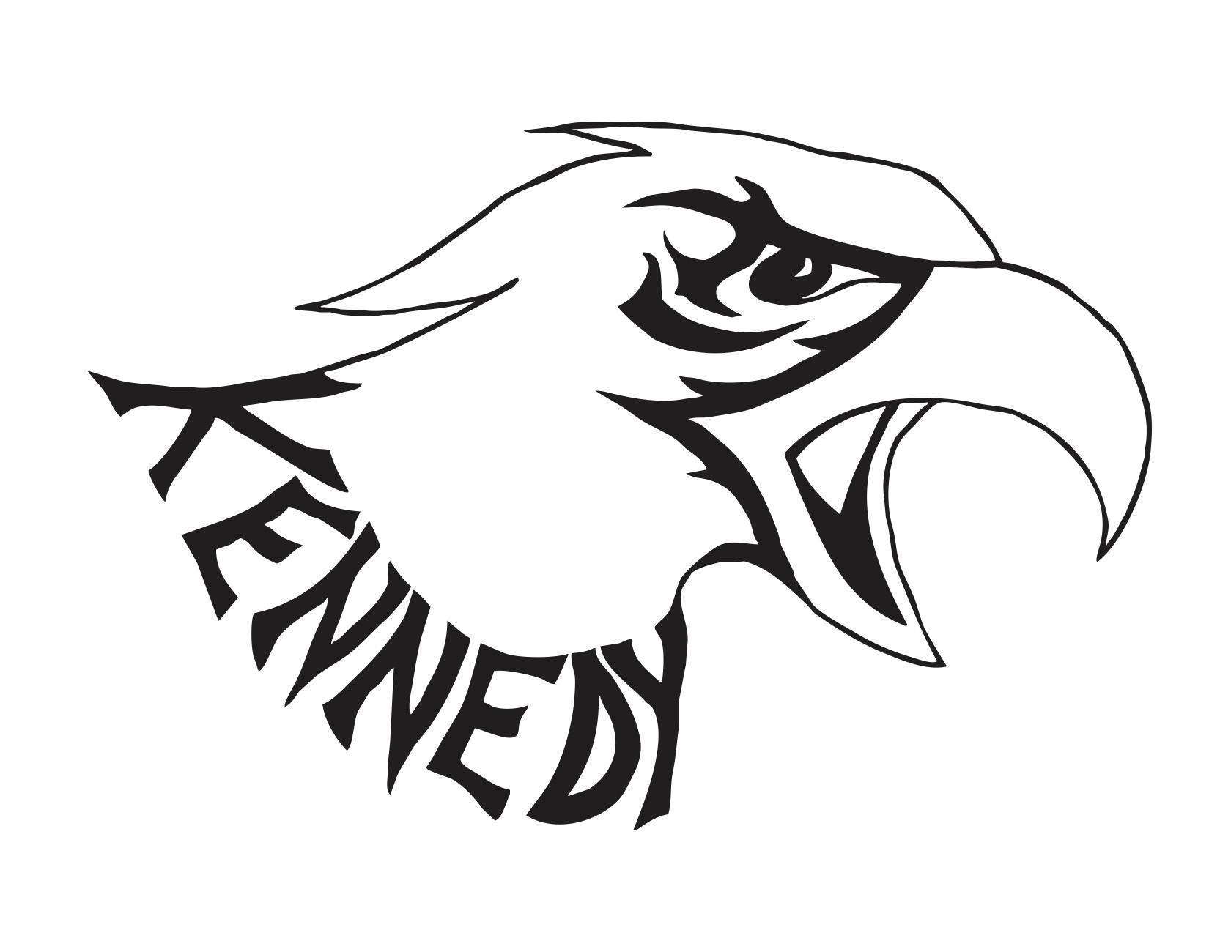
Kennedy Elementary PTA Meeting Agenda
September 12, 2018
Called to order at 7:06 pm

Attendees:

Jennifer Exley President
Anne Williams Treasurer
Monique Bull Secretary
Pam Hughes Principal
Elizabeth Chavez Teacher Rep
Sarah LaFrentz Teacher Rep
Teri Hastrings
Melissa Wilson
Hilary Donohue
Carrie Harris
Jessica Rose
Kristen Brand
Cindy Plante
Ish Keur
Daisy Gutierrez
Paula Silva
Mary Teryeira
Misha Agarwal
Charanya Sivakumar

Leslie Feyling
Melanie Young
Camille Cheng
Chrissy Ogimachi
Isleem De Torres
Gio De Torres
Yongsian Jin
Sanjeev Chakravarty
Karusha
Adriena Brown
Michael Brown
Rose Kaur Sahi
Anna Zeiber
Catherine Stuart
Angela Ringlien

- Jennifer Exley called meeting to order at 7:06pm
- Jennifer made Introductions, PTA Board, Principal, Teacher Reps: Liz Chaves and LeFrentz
- Pam Hughes
  - Announced the Back to school night and general process of the night, bake sale and book fair
  - Announced Traffic Safety assembly going on for the students
  - Wed Night – school sight council – in need of more parent volunteers, went over the involvement and what to expect of council duties. Covered how to apply to be on the council and how to get elected in.
  - Picture day on 9/19 – bring change of clothes so dressy clothes do not get damaged
  - Newark Day Parade Announcement – Join us!
- Cindy – Covered what the event is about, brings in $10,000 a year. Date- When should we schedule for the event, before or after harvest fest? Nov 2nd would be tentative date.
    - In need of Co-Chair to assist Cindy, coordination of events earned by event. Contact Cindy or Jennifer if you are interested.
    - Suggestion- For fast younger(Tk/K) runners to have more recognition, doing 40+ laps in a fast time, do something for them to acknowledge their efforts
    - Birch grove – teacher created a lap counter and we have interested in renting the lap counter, Fee would be involved for lanyards
    - Addressing the late comers for event – possible incentive for people on time for turning in their forms/permission slip, possible google form to be sent out.
- Laura was sick, Anne spoke about Art show, April 12th evening event – Requesting help with roles, some at home roles and some at show/school help. Passed around an interest/help list.
    - Did art show make more money than previous years? Yes, we warned $3,700. Earned $1,000 from just the raffle
      - Sold out on donation bags and ordered bags when sold out

- Anne Williams & Leslie Feyling went over budget documents
  - Covered Budget comparison sheet for end of year budget
    - Last school year, reviewed form from last year covering what we earned vs. expected to earn. *clarified the money earned from the art show went to the art fund*
    - Addressed why we discontinued the gift card program – earning 1% of profit due to shipping costs
    - Pie Chart – reviewed document – what we earned and how we spent percentage wise
  - Treasures report ledger – May -June 28th, Checks 2947-2976 – All Ay – Checks Approved
  - From a questionnaire sent out at the end of the year, Anne made a plan of what would be spent this year based on interest. Teacher’s to supply what they are interested in spending money on.
    - Pam said Balls Hula Hoops, Teather balls, jump ropes would be desired for recess play
    - School requested we pay for half of the Soul Shop Assembly – Anti-Bullying - $1,500
    - Interest in helping the Science classes, previous years PTA has funded one-year PE and the next year Science, This year we will be giving $1,000 to bump the Science classes.
    - Suggested $5,000 for classroom replacement devices/technology – however there are talks of possibly school district to replace all classroom tech. Budget on hold until there is confirmation of district plans
    - Pam requested set of 10 walkie talkies to add to current set for more teachers to be connected and contactable – Approve the walkie talkies to night -
  - Audit – Leslie – Ran audit – PTA is in good standing – Presenting for adoption -
  - Release of Funds - All Ays – Release of funds approved
    - $400 Art Canvases and Supplies
    - $500 Tax Preparation
    - $2150 Spiritwear
    - $2700 Scholastic News
    - $1500 Harvest Festival Supplies
    - $200 for Walkie Talkies

- No room parents for Mrs. Blakely, Babbage, Martinez or Chan classrooms. Looking for volunteers
- Do teachers want to continue to receive construction paper from PTA? Liz Chavez Will take the question to the teachers and will report back to PTA
  - Sports update -4th thru 6th – Coach C will take on for the teams – except for girls sports
  - Yes for Chess – are note planning a fall session but will be back in Jan
  - Harvest Festival - October 26th, need volunteers – Kids can come in costume as it is close to Halloween – Krissy will be assisting Jen in putting it on today
    - Help needed for before during and after planning.
    - Has a list for sign-ups
  - Newark Days Parade – Catherine – Sept 22nd morning – suggested waiting activates – no float – Theme Wizarding World
    - Showed a banner and signs
    - Brought witch/wizard hats to have for kids to wear
    - Suggested bringing wagons if kids need a break
    - Shared that Mandy in the front office has information as well
    - School will send home a flyer – just want people to show up and help support school – bring kids at 8:45 so kids are not waiting too long to start

- Jen went over the duties of the positions that we are looking for volunteers
  - Walk-a-Thon Assistant – Addressed above
  - Field Day Coordinator (assistant?) – June Event, looking for a volunteer

- Open Discussion
  - Phishing PTA Scams – Anne received an email that addressed scams asking for wiring funds to someone one claiming they are part of PTA
  - Tax Preparation – Addressed above
  - Scholarship Available for Continuing Education – Eligible for scholarship after 3 years of volunteering for 3 + years
  - Membership Class Contest – Kevisha running membership this year. Jen covered the school competition and the awards for the top 3 winners
  - Donation Magnets – Jen went over the reasoning of why we started donations, in an effort to reduce fundraising. Magnet is earnable with a $40 donation
  - ED100 Presentation – Anne circulated the website on Facebook. 10 lessons on education in California. Opens up discussion of what we do at our school and what other California schools do.
    - Went over what state testing we do
    - California school dashboard
- Questions:
  - Any more information for Stem enrichment? No, information supplied to the school just yet but Pam did go over the Stem enrichment in the plans. If it starts it will run from Oct to Feb
  - Was maker cart purchased? Yes, it has been and will be in use this year.
  - Are meeting the 2nd wed of the month? Yes. Next meeting is Oct 10th @ 7pm
- Meeting Called to an end -8:20 pm

